**Lab work for Multiple Inheritance**

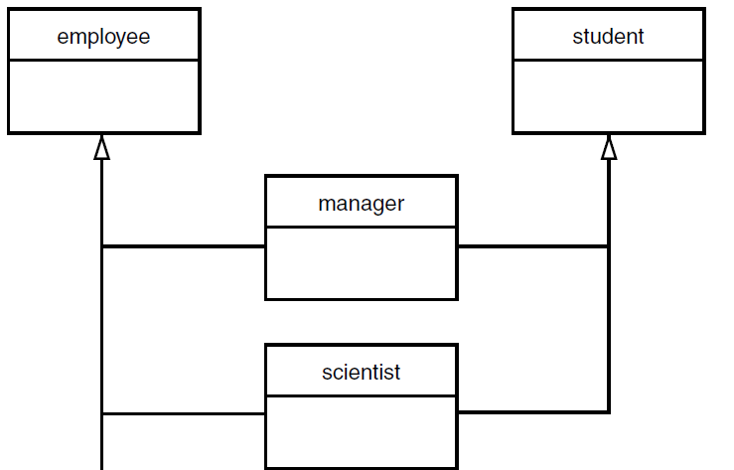

Student

Employee

t

Scientist

Manager

Student

Program

DateCompletion

Putdata()

Getdata()

Scientist

researchArea

NamePub

datePublication

Putdata()

Getdata()

Manager

Designation

Salary

Putdata()

Getdata()

Class Employee

EmpID

EmpName

Putdata()

Getdata()

**To generate this output by using the class public inheritance concept. Use the following these two class.**

**Base class Employee & derived class Salary**

Output:

Enter the Number of employee:1

Enter the employee No: 150

Enter the employee Name: ram

Enter the designation: Manager

Enter the basic pay: 5000

Enter the HR allowance: 1000

Enter the Dearness allowance: 500

Enter the profitability Fund: 300

E.No   E.name   des      BP    HRA   DA   PF     NP

150    ram      Manager  5000  1000  500  300    6200